Managing the Standards Main Page

## Content Element

The content element is located in the “Normal” section of the template. The process for creating the table is the same as for the [Activities main page](https://docs.google.com/a/infielddesign.com/document/d/1i_UdlhjKzIfhiTJ03cKdqxSEAvWj9qYlFfhW_dibrxA).

The difference on the Standards main page is that there are several different headings, each with a table underneath.

### Create the Section

1. Type your heading text, including the asterisk for the link to the “Status and Categories” page

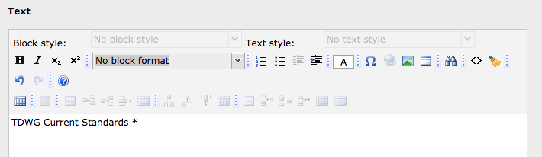

1. Highlight the text and choose “Heading 1” from the block format drop-down.

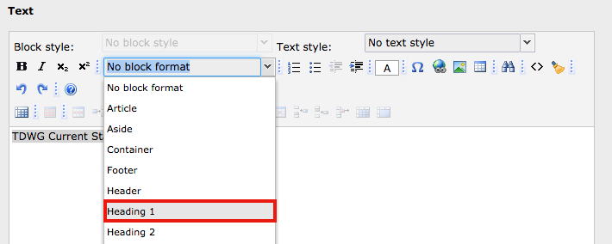

1. To make the asterisk a link, highlight it and click the “Link” button in the toolbar

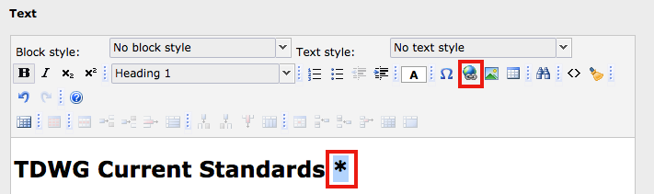

* 1. In the Insert Link dialog, choose the “Page” option if that was not the default. Open the Page Tree until you locate the page you want to link to, and click on the page. This will create the link. The default is for the links to be created in the same window. To have them open in a new window, change the selection in the “Style” drop down.

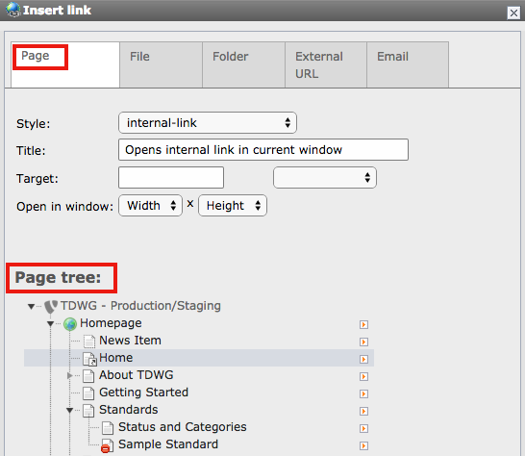

1. Add the table, following the instructions from [Activities main page](https://docs.google.com/a/infielddesign.com/document/d/1i_UdlhjKzIfhiTJ03cKdqxSEAvWj9qYlFfhW_dibrxA).
2. Repeat steps 1-4 for each section of standards.